

Updating BIOS and Licensing

Evan Choi | Cisco Cybersecurity | 10/30/2022

**Purpose**

The purpose of this lab is to update the PAN-OS and licensing on your Palo Alto Firewall to the latest version for optimal security.

**Background Information on lab concepts**

PAN-OS or Palo Alto Network Operating System is an operating system based on Linux which provides a secure, enterprise grade environment that allows Palo Alto network security capabilities to be executed. The newest PAN-OS version is 10.2 which collects, analyzes and interprets potential threats in real time. This version provides six times faster prevention and 48% more evasive threat detection than before.

Retrieving a license for a Palo Alto firewall is a crucial step to being able to download PAN-OS software images directly from the update server. To obtain these licenses, you buy them from the Palo Alto website. The address of the update server is updates.paloaltonetworks.com, so when you are trying to activate or fetch a license, you must set that as the update server. There are various different licenses you can buy such as GlobalProtect, Device Dictionary, and WildFire, and each have different functions and features.

**Lab Summary**

In this lab, I used a Palo Alto PA220 firewall and 3 ethernet cables to connect the firewall to internet and jumper the management port to LAN. After accessing the web GUI, I retrieved the license and performed software updates. We used three different licenses in this lab, which include GlobalProtect (Clientless VPN & Data File), Device Dictionary, and WildFire.

**Network Diagram**

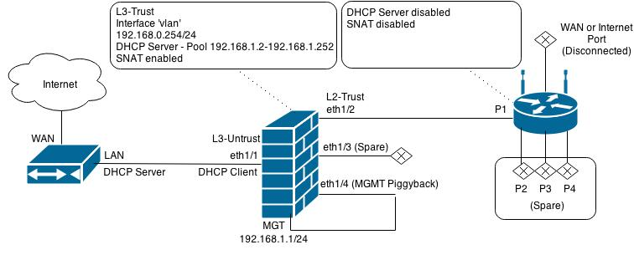

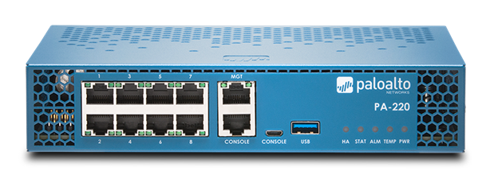



**Procedure**

1. First go to the **License** menu, and under **Devices** click **Licenses.**

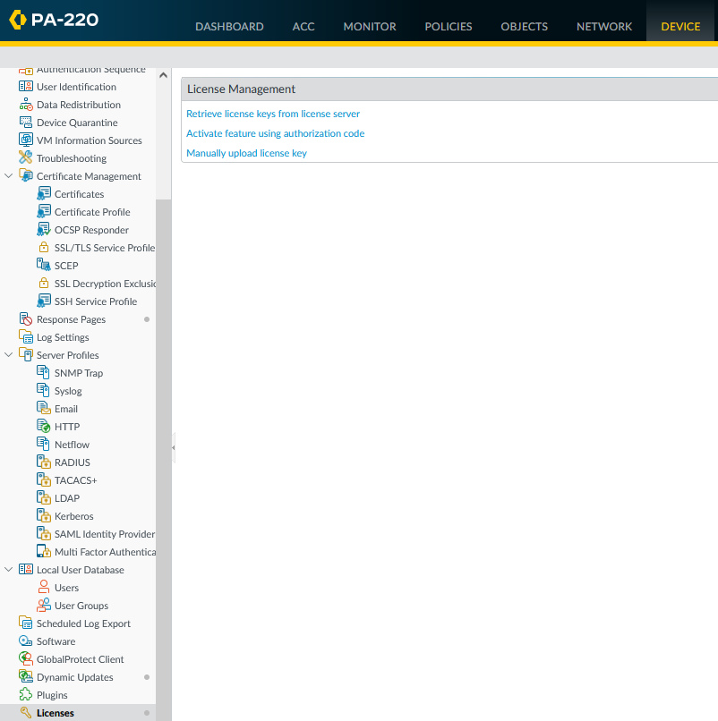

1. You may get a error when attempting to receive license keys, in which case is most likely a DNS server issue.

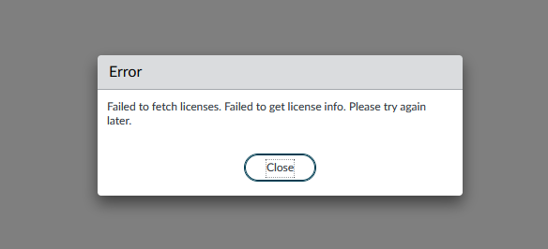

1. To fix this, go to **Device>Setup>Services** to view the DNS service options. Select the gear icon in the top right to perform edits

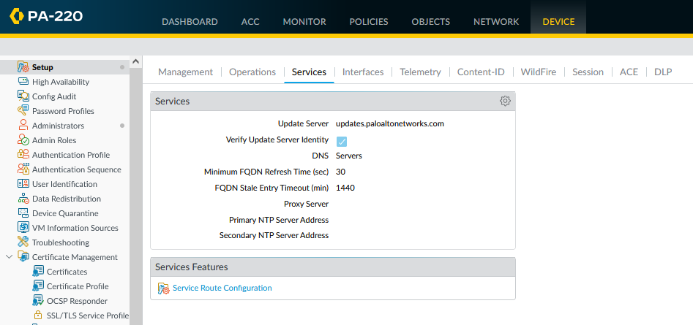

1. Change the Primary DNS Server and Secondary DNS Server to one that works. I working DNS is the Google Public DNS, which has a primary address of 8.8.8.8 and a secondary address of 8.8.4.4.

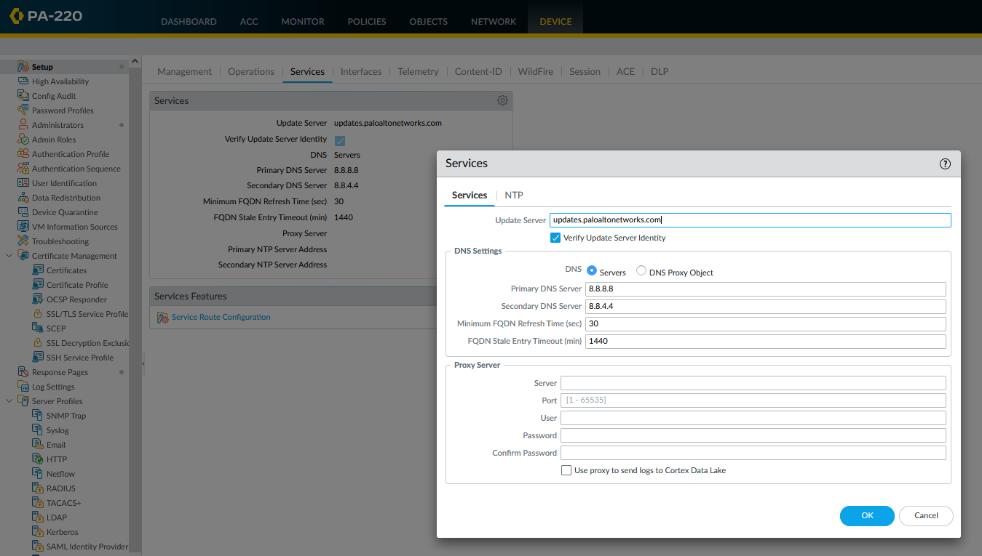

1. After attempting to retrieve license data again, they appeared.

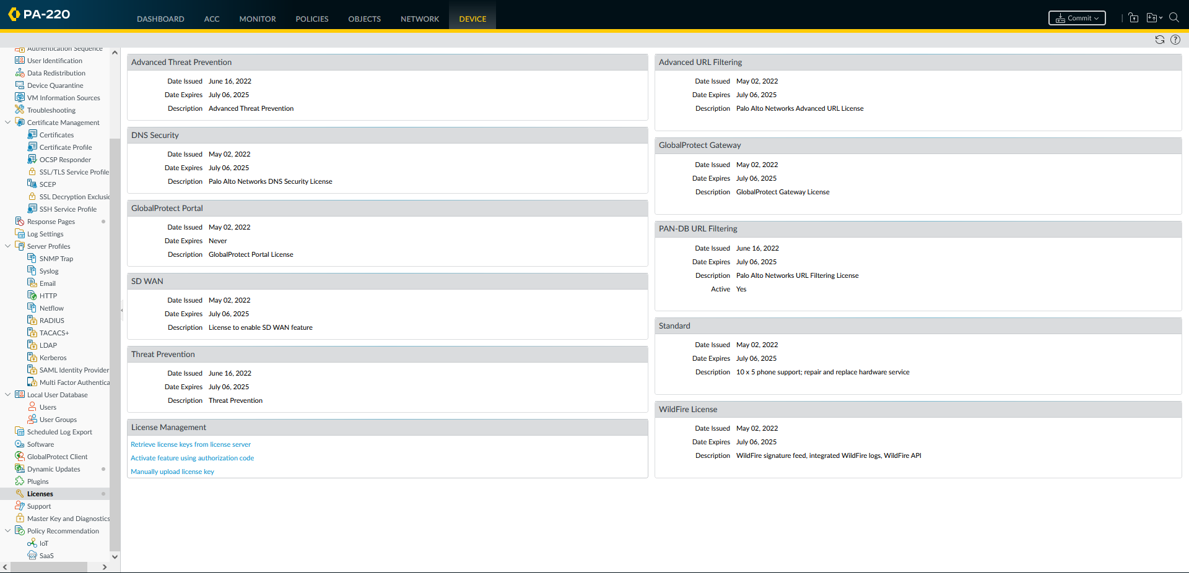

1. The Dynamic Updates are above. Download and install the most recent version in each category.



1. When downloading a dynamic update, it should look something like this. This is an example of downloading the new version of GlobalProtect Clientless VPN.



1. Download and install all dynamic updates. It should look like this after.

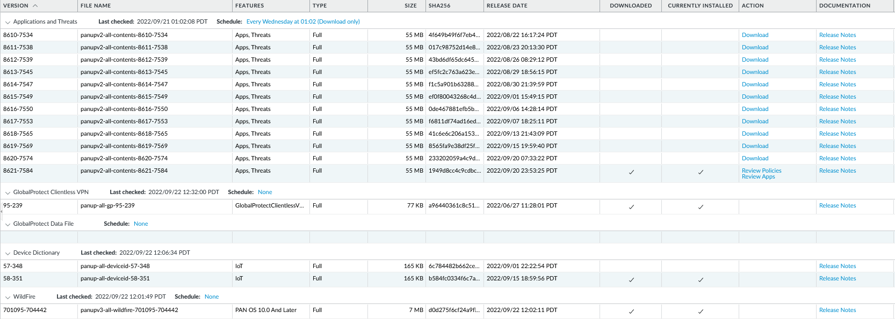

1. In the **Device>Software** section, click the **Check Now** button to refresh the software version list. All OS versions should appear.

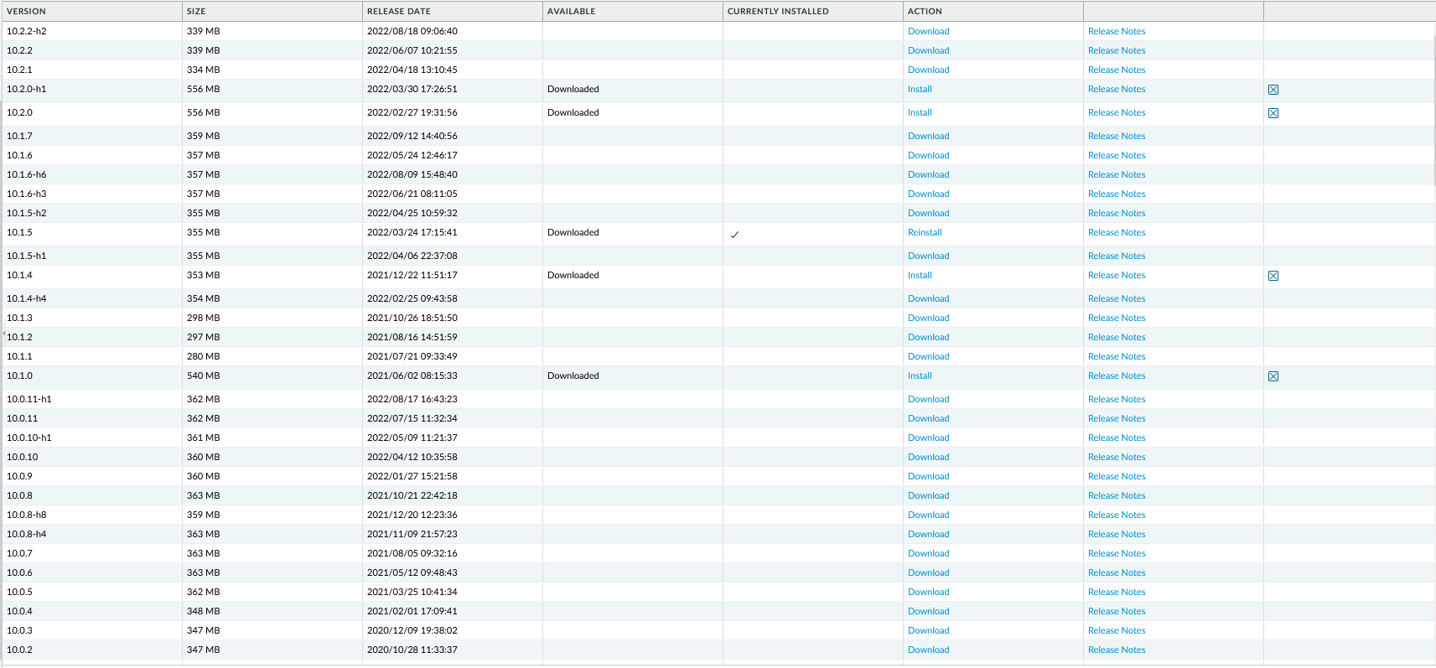

1. You will have to download the newest version for each version segment. Since the version after the factory reset was 10.1.5, we downloaded 10.1.7 before downloading the 10.2.1 segment.

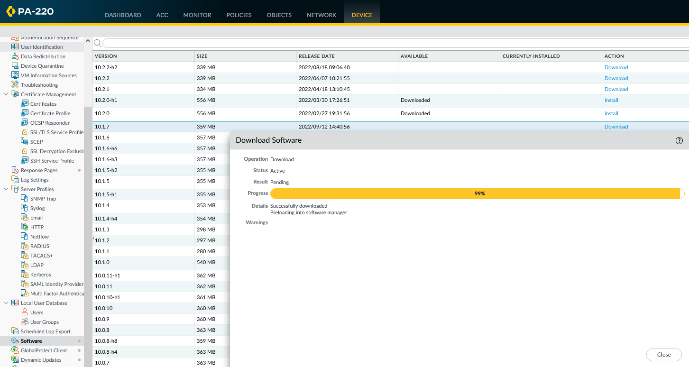

1. Afer each update, you must install an update. Below is the installation status for installing the 10.1.7 version.

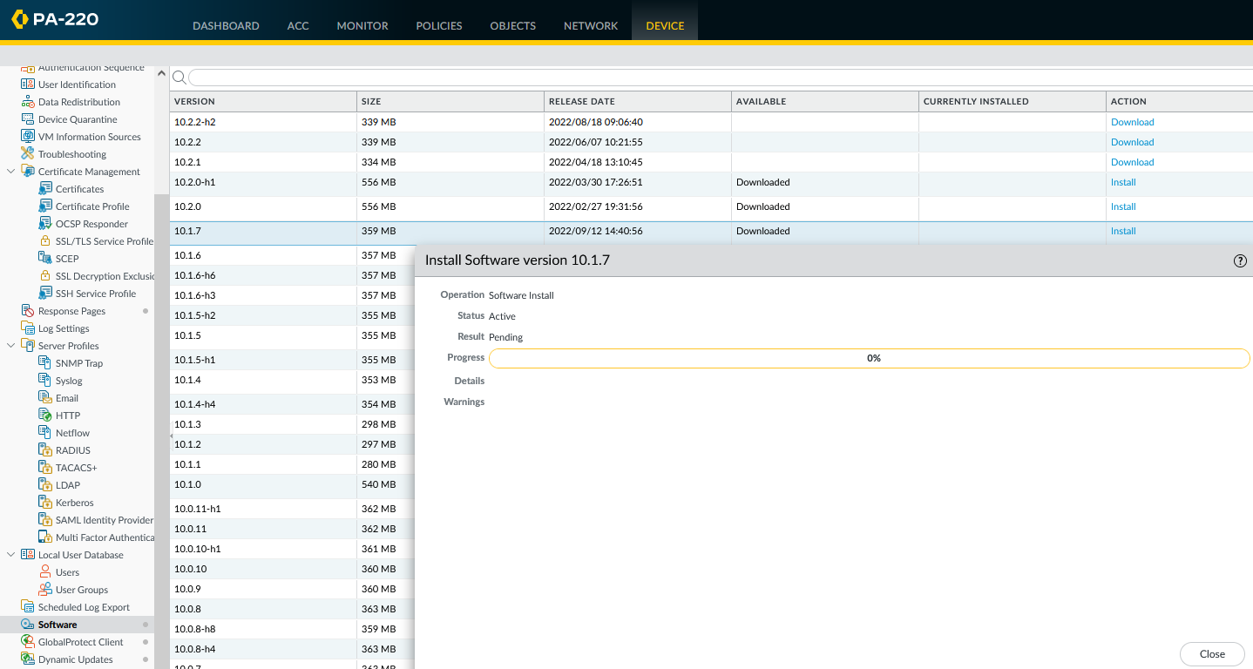

1. You must perform a reboot between each OS version installation. This will take about 10-15 minutes.

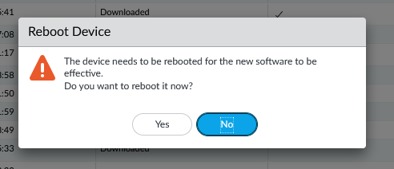

1. Repeat this process for 10.2.1 and 10.2.2 to get the most recent version. In the image below, the most recent version has been installed.

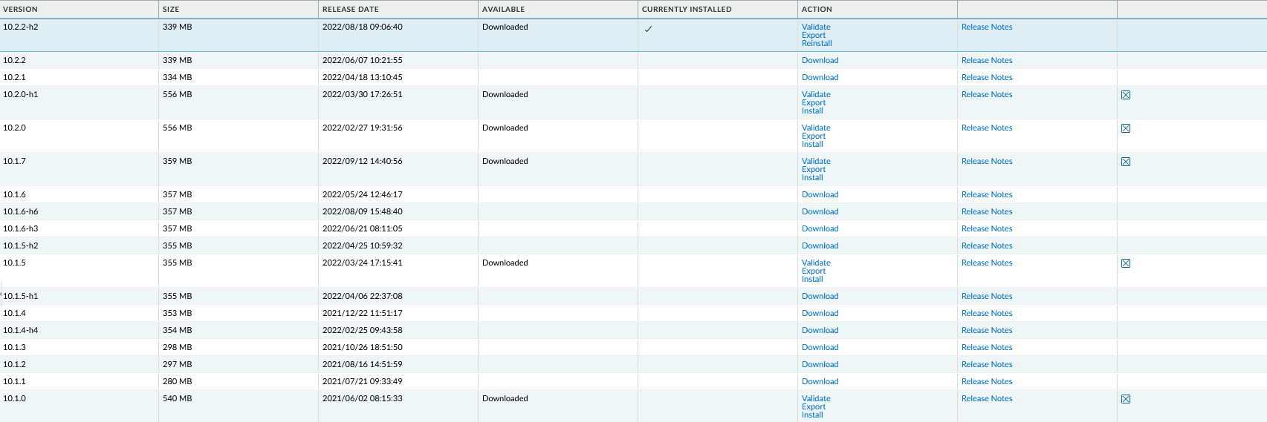

**Problems**

A problem I faced during this lab was reaching the server. When attempting to fetch licenses, I got an error message saying, “Failed to fetch license. Failed to get license info. Please try again later,” preventing me from fetching the licenses I needed to update the software.

I decided to look back at my services setup. Looking at it, I noticed that my DNS wasn’t set. I tried setting the primary DNS as 4.4.4.4 but that didn’t work, so I looked up other DNS public resolvers and found the Google one, which was 8.8.8.8 as the primary DNS and 8.8.4.4 as the secondary. After making these changes, I tried to fetch licenses and it worked.

**Conclusion**

PAN-OS is an operating system based on Linux which provides a secure, enterprise grade environment that allows Palo Alto network security capabilities to be executed. In order to download PAN-OS software images directly from the update server, you must purchase a license from the Palo Alto website. While retrieving licenses and updating the software, you will have to go through the whole installation process, which includes rebooting your device after each update. Although I was having problems fetching licenses, I was able to eventually figure out how to successfully obtain them, which included setting a primary and secondary DNS server. Through this lab I learned how to fetch a license and update the PAN-OS software manually, as well as learning the different features of the licenses I utilized.

**Teacher Signoff Page of Lab Completed**

The stamp below recognizes that

Evan Choi

has completed

**Lab 3 – Licensing and Software Update**

 Adv Cisco Cybersecurity – Mr. Mason & Mr. Hansen

Period 5